## Version Control System (VCS) Interview Questions

Now let’s look at interview questions on VCS:

## Q1. What is Version control?

This is probably the easiest question you will face in the interview. My suggestion is to first give a definition of Version control. It is a system that records changes to a file or set of files over time so that you can recall specific versions later. Version control systems consist of a central shared repository where teammates can commit changes to a file or set of file. Then you can mention the uses of version control.

Version control allows you to:

* Revert files back to a previous state.
* Revert the entire project back to a previous state.
* Compare changes over time.
* See who last modified something that might be causing a problem.
* Who introduced an issue and when.

## Q2. What are the benefits of using version control?

I will suggest you to include the following advantages of version control:

1. With Version Control System (VCS), all the team members are allowed to work freely on any file at any time. VCS will later allow you to merge all the changes into a common version.
2. All the past versions and variants are neatly packed up inside the VCS. When you need it, you can request any version at any time and you’ll have a snapshot of the complete project right at hand.
3. Every time you save a new version of your project, your VCS requires you to provide a short description of what was changed. Additionally, you can see what exactly was changed in the file’s content. This allows you to know who has made what change in the project.
4. A distributed VCS like Git allows all the team members to have complete history of the project so if there is a breakdown in the central server you can use any of your teammate’s local Git repository.

## Q3. Describe branching strategies you have used.

This question is asked to test your branching experience so tell them about how you have used branching in your previous job and what purpose does it serves, you can refer the below points:

* Feature branching  
  A feature branch model keeps all of the changes for a particular feature inside of a branch. When the feature is fully tested and validated by automated tests, the branch is then merged into master.
* Task branching  
  In this model each task is implemented on its own branch with the task key included in the branch name. It is easy to see which code implements which task, just look for the task key in the branch name.
* Release branching  
  Once the develop branch has acquired enough features for a release, you can clone that branch to form a Release branch. Creating this branch starts the next release cycle, so no new features can be added after this point, only bug fixes, documentation generation, and other release-oriented tasks should go in this branch. Once it is ready to ship, the release gets merged into master and tagged with a version number. In addition, it should be merged back into develop branch, which may have progressed since the release was initiated.

In the end tell them that branching strategies varies from one organization to another, so I know basic branching operations like delete, merge, checking out a branch etc.

## Q4. Which VCS tool you are comfortable with?

You can just mention the VCS tool that you have worked on like this: “I have worked on Git and one major advantage it has over other VCS tools like SVN is that it is a distributed version control system.”  
Distributed VCS tools do not necessarily rely on a central server to store all the versions of a project’s files. Instead, every developer “clones” a copy of a repository and has the full history of the project on their own hard drive.

## Q5. What is Git?

I will suggest that you attempt this question by first explaining about the architecture of git as shown in the below diagram. You can refer to the explanation given below:

* Git is a Distributed Version Control system (DVCS). It can track changes to a file and allows you to revert back to any particular change.
* Its distributed architecture provides many advantages over other Version Control Systems (VCS) like SVN one major advantage is that it does not rely on a central server to store all the versions of a project’s files. Instead, every developer “clones” a copy of a repository I have shown in the diagram below with “Local repository” and has the full history of the project on his hard drive so that when there is a server outage, all you need for recovery is one of your teammate’s local Git repository.
* There is a central cloud repository as well where developers can commit changes and share it with other teammates as you can see in the diagram where all collaborators are commiting changes “Remote repository”.

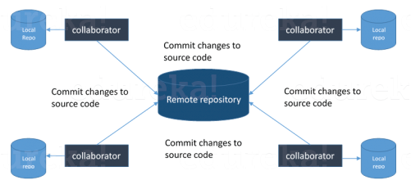

## Q6. Explain some basic Git commands?

Below are some basic Git commands:

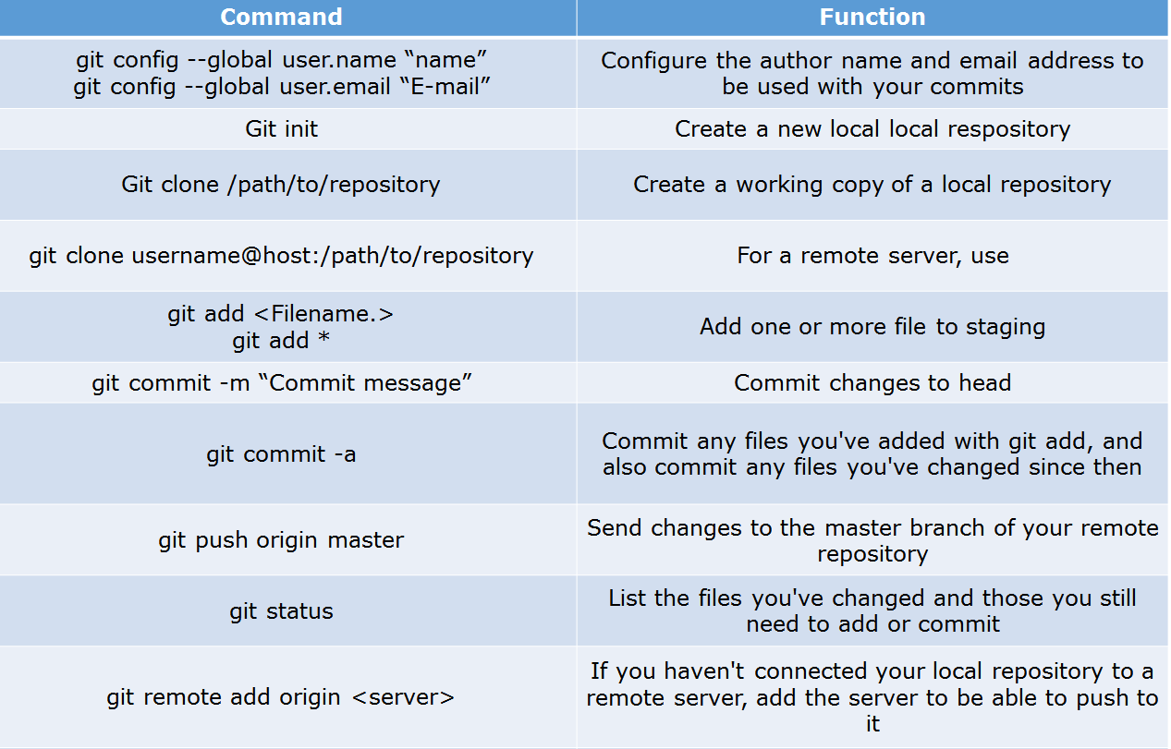

## Q7. In Git how do you revert a commit that has already been pushed and made public?

There can be two answers to this question so make sure that you include both because any of the below options can be used depending on the situation:

* Remove or fix the bad file in a new commit and push it to the remote repository. This is the most natural way to fix an error. Once you have made necessary changes to the file, commit it to the remote repository for that I will use  
  git commit -m “commit message”
* Create a new commit that undoes all changes that were made in the bad commit.to do this I will use a command  
  git revert <name of bad commit>

## Q8. How do you squash last N commits into a single commit?

There are two options to squash last N commits into a single commit. Include both of the below mentioned options in your answer:

* If you want to write the new commit message from scratch use the following command  
  git reset –soft HEAD~N &&  
  git commit
* If you want to start editing the new commit message with a concatenation of the existing commit messages then you need to extract those messages and pass them to Git commit for that I will use  
  git reset –soft HEAD~N &&  
  git commit –edit -m”$(git log –format=%B –reverse .HEAD@{N})”

## Q9. What is Git bisect? How can you use it to determine the source of a (regression) bug?

I will suggest you to first give a small definition of Git bisect, Git bisect is used to find the commit that introduced a bug by using binary search. Command for Git bisect is  
git bisect <subcommand> <options>  
Now since you have mentioned the command above, explain what this command will do, This command uses a binary search algorithm to find which commit in your project’s history introduced a bug. You use it by first telling it a “bad” commit that is known to contain the bug, and a “good” commit that is known to be before the bug was introduced. Then Git bisect picks a commit between those two endpoints and asks you whether the selected commit is “good” or “bad”. It continues narrowing down the range until it finds the exact commit that introduced the change.

## Q10. What is Git rebase and how can it be used to resolve conflicts in a feature branch before merge?

According to me, you should start by saying git rebase is a command which will merge another branch into the branch where you are currently working, and move all of the local commits that are ahead of the rebased branch to the top of the history on that branch.  
Now once you have defined Git rebase time for an example to show how it can be used to resolve conflicts in a feature branch before merge, if a feature branch was created from master, and since then the master branch has received new commits, Git rebase can be used to move the feature branch to the tip of master.  
The command effectively will replay the changes made in the feature branch at the tip of master, allowing conflicts to be resolved in the process. When done with care, this will allow the feature branch to be merged into master with relative ease and sometimes as a simple fast-forward operation.

## Q11. How do you configure a Git repository to run code sanity checking tools right before making commits, and preventing them if the test fails?

I will suggest you to first give a small introduction to sanity checking, A sanity or smoke test determines whether it is possible and reasonable to continue testing.  
Now explain how to achieve this, this can be done with a simple script related to the pre-commit hook of the repository. The pre-commit hook is triggered right before a commit is made, even before you are required to enter a commit message. In this script one can run other tools, such as linters and perform sanity checks on the changes being committed into the repository.  
Finally give an example, you can refer the below script:  
#!/bin/sh  
files=$(git diff –cached –name-only –diff-filter=ACM | grep ‘.go$’)  
if [ -z files ]; then  
exit 0  
fi  
unfmtd=$(gofmt -l $files)  
if [ -z unfmtd ]; then  
exit 0  
fi  
echo “Some .go files are not fmt’d”  
exit 1  
This script checks to see if any .go file that is about to be committed needs to be passed through the standard Go source code formatting tool gofmt. By exiting with a non-zero status, the script effectively prevents the commit from being applied to the repository.

## Q12. How do you find a list of files that has changed in a particular commit?

For this answer instead of just telling the command, explain what exactly this command will do so you can say that, To get a list files that has changed in a particular commit use command  
git diff-tree -r {hash}  
Given the commit hash, this will list all the files that were changed or added in that commit. The -r flag makes the command list individual files, rather than collapsing them into root directory names only.  
You can also include the below mention point although it is totally optional but will help in impressing the interviewer.  
The output will also include some extra information, which can be easily suppressed by including two flags:  
git diff-tree –no-commit-id –name-only -r {hash}  
Here –no-commit-id will suppress the commit hashes from appearing in the output, and –name-only will only print the file names, instead of their paths.

## Q13. How do you setup a script to run every time a repository receives new commits through push?

There are three ways to configure a script to run every time a repository receives new commits through push, one needs to define either a pre-receive, update, or a post-receive hook depending on when exactly the script needs to be triggered.

* Pre-receive hook in the destination repository is invoked when commits are pushed to it. Any script bound to this hook will be executed before any references are updated. This is a useful hook to run scripts that help enforce development policies.
* Update hook works in a similar manner to pre-receive hook, and is also triggered before any updates are actually made. However, the update hook is called once for every commit that has been pushed to the destination repository.
* Finally, post-receive hook in the repository is invoked after the updates have been accepted into the destination repository. This is an ideal place to configure simple deployment scripts, invoke some continuous integration systems, dispatch notification emails to repository maintainers, etc.

Hooks are local to every Git repository and are not versioned. Scripts can either be created within the hooks directory inside the “.git” directory, or they can be created elsewhere and links to those scripts can be placed within the directory.

## Q14. How will you know in Git if a branch has already been merged into master?

I will suggest you to include both the below mentioned commands:  
git branch –merged lists the branches that have been merged into the current branch.  
git branch –no-merged lists the branches that have not been merged.